Pack Description

The application of lithium battery is widely used in communication products, industrial equipment, home energy storage, solar energy storage. Different products require different voltages and capacities, so lithium ion batteries are connected in series and parallel. Lithium batteries are equipped with BMS, shell and output to form a battery PACK called pack. PACK can be a single battery, such as 18650, 26650,32700 21700 single series lithium battery with protective plate. It can also be a series and parallel combination Battery, such as golf cart Lithium Battery, medical device battery, Home Energy Storage Lithium Battery, electric vehicle battery, Mounted Solar System Lithium ion Battery, UPS battery, etc.Stackable Home Energy Backup

1. Composition of PACK:

PACK consists of a battery group, BMS, outer packaging or shell, output (including connectors), power indicator, EVA, highland barley paper, plastic support and other auxiliary materials to form PACK. PACK's external features are determined by the application. There are many kinds of packs

Features of PACK

★ Maintenance free

★ Battery PACK requires the battery to have a high degree of consistency (capacity, internal resistance, voltage, discharge curve, life).

★ The cycle life of the battery PACK is lower than that of a single battery.

★ Use under limited conditions (including charging, discharging current, charging mode, temperature, humidity conditions, vibration, stress degree, etc.)

★ The lithium battery PACK protection plate must have the charge balancing function.

★ High-voltage and high-current battery packs (such as electric vehicle batteries and energy storage systems) are required to be equipped with communication buses such as battery management system (BMS), CAN, RS485, etc.

★ The battery PACK has high requirements on the charger, and some requirements can communicate with the BMS. The purpose is to make each battery work normally, give full play to the stored energy of the battery, and ensure the safe and reliable use.

4. Design of PACK

★ Fully understand the application requirements, such as application environment (temperature, humidity, vibration, salt spray, etc.), service time, charging, discharging mode and electrical parameters, output mode, life requirements, etc.

★ Select qualified battery and protection circuit board according to use requirements.Meet the requirements of size and weight.
★ Reliable packaging, meet the requirements.
★ Simple production process.

Ii. Introduction of important components

1. Battery pack

★ Composition: The battery is formed by a single battery and connected in series. Parallel increase capacity, the voltage is unchanged, after series voltage doubling, the capacity is unchanged, such as 3.6V/10Ah battery is composed of a single N18650/2Ah through 5 parallel, 36V/2Ah battery can be composed of a single N18650/2Ah through 10 series, A 36V/10Ah battery consists of a single N18650/2Ah battery connected in parallel with 5 and 10 in series.

★ Combination requirements: Parallel and series batteries require the same model, the difference in capacity, internal resistance and voltage value is not more than 2%. The essence is the consistency of the battery charge and discharge curve (dynamic consistency). But it is difficult to do, under normal circumstances, after the battery through parallel series combination, the capacity loss of 2%~5%, the more the number of batteries, the more capacity loss.
★ Combination realization: the combination of the battery through two ways to achieve, one is through nickel spot welding or laser welding or ultrasonic welding, this is commonly used means, the advantage is good reliability, but not easy to replace. The second is through the elastic metal sheet contact, the advantage is that there is no need to weld, the battery replacement is relatively easy, the disadvantage is that it may lead to poor contact.
★ Requirements: The battery pack should meet the requirements of the user's working time, environment, vibration, charging, service life, etc. Do not use the battery string alone. Overcharging, overdischarging, or overcurrent may damage the battery. , need to be equipped with a special protection plate can be used.

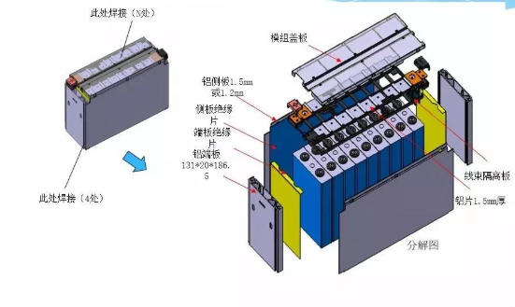
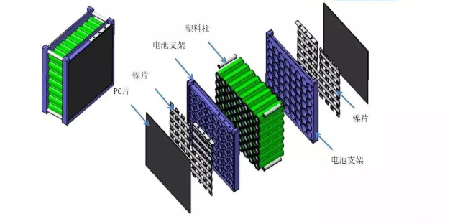

2. BMS

★ Composition: Protection board by protection IC, MOSFET, transistor, resistor and capacitor and PCB and heat dissipation device.
★ Function: Protect the battery working in normal condition. Prevent the battery due to overcharge, overdischarge, short circuit and other causes of battery failure and smoke, fire, explosion caused by the risk.
★ Specific functions:

A. Overcharge protection. The overcharge protection voltage of batteries of different systems is different. In general, the overcharge protection voltage of lithium iron phosphate is 3.65V~3.85V, and the overcharge protection voltage of lithium cobalt oxide, lithium manganese oxide and terpolymer lithium batteries is 4.2V~4.35V.

B, overdischarge protection, the overdischarge protection voltage of lithium iron phosphate is 2~2.5V, the other three kinds of lithium batteries are 2.3V~2.9V.
C. Short circuit protection. It is determined by the IC and MOSFET parameters. Different IC and MOSFET have different short circuit protection values.
D, overcharge protection voltage recovery. IC has this function, the general recovery voltage is lower than the protection voltage 0.1-0.2V.
E. Recovery voltage of overdischarge protection. Some ics do not have this function. After overdischarge, it needs to be restored by charging.
F. Short circuit protection delay time. Generally ten milliseconds.
G. Balancing function. Some applications require balancing functions. Because the battery discharge current is large, the balance is not easy to achieve, most of the current charge balance, the purpose of balance is to ensure that each battery can be fully charged, extend the service life, maximize the role of the battery.

★ Use of BMS:

A The protection plate is connected to the battery. The lithium battery cannot be used alone without the protection plate.

B Pay attention to the effective isolation between the protection plate and the battery, to play the role of insulation and heat insulation.

C When installing multiple protection boards and batteries, connect them in the sequence of low level first and high level later. That is, connect B- first, then B1, B2...... B9, and then B plus. See the picture below.
When removing the protective plate, the installation sequence is reversed.

